CPS209 Assignment 1:

Grocery Store Simulator

Due Date: Mon., Mar. 19 11:59pm

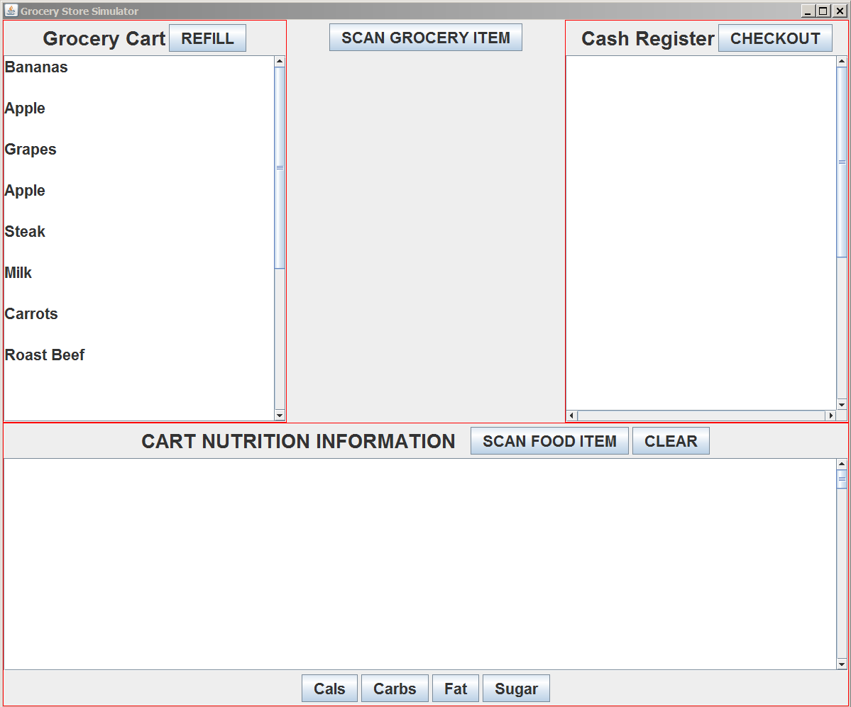

You are to write a Grocery Store Simulator program. This programming assignment will increase your knowledge of objects and classes, inheritance, interfaces, and GUIs. You must do this assignment alone – no groups. Do not attempt to find source code on the web for this assignment. It will not help you and you risk extremely serious consequences. Your program will be checked for plagiarism. Begin designing and programming early! This assignment is worth 10 percent of your mark. If there is some part of the assignment you do not understand, please see me (or email me) or ask me in the lecture as soon as possible and I will clarify the issue.

Program Functionality Requirements:

Please review the two example programs in the GUI documents folder: FontViewer GUI (also presented in chapter 11 of the textbook) and InvestmentViewer3. I suggest you to use these programs as a guide to building GUI programs. I am also providing the simple viewer class for your program called GroceryStoreViewer. Below are the main classes for your assignment and suggested list of methods and variables. Some variables are required so please read carefully. I strongly suggest you build your program in pieces. Get one piece compiled and working before working on the next piece. Read the marking scheme below and use it as a guide.

Create a class GroceryItem. Class GroceryItem should contain instance variables label (of type String) and price (of type double) and foodCode (of type int). You can just make up some foodCode numbers for several types of food. These foodCodes will also be used in the Nutrition part described below. Here are some suggested methods for class GroceryItem:

A constructor method that takes a foodCode, label and price as parameters.

Get and Set methods for the instance variables

Create at least two subclasses of GroceryItem - Dairy and Meat. Dairy has an additional variable volume and a Dairy object’s price is determined by multiplying the price variable by the volume (i.e. it overrides the getPrice() method defined in GroceryItem). Similarly, class Meat has a weight variable and it also overrides the getPrice() method to determine price.

Create a class GroceryCart. Class GroceryCart contains an array list of GroceryItem objects (some of which might be Meat objects or Dairy objects). Class GroceryCart should have methods such as: addItem(GroceryItem item)- adds item to array list, fill() - which creates 10-12 different types of GroceryItem objects with prices and labels and food codes and adds them to the arraylist (i.e. “fills up the cart), removeTopItem() which removes the top GroceryItem object from the arraylist and returns a reference to it. A method such as display(JTextArea area) is useful as it goes through the GroceryItem objects in the array list and displays them in the given text area. In addition, you will need to set up a method that returns the next grocery item object in the list but does not remove it from the list. You will also need a separate variable inside the GroceryCart class to keep track of the next item and a method to reset this next item variable. This variable and these two methods are used by the Nutrition Scanner class described below. Note: you do not this functionality if you are not planning on implementing the Nutrition Scanner functionality.

Create a class CashRegister. Class CashRegister also contains an (initially empty) array list of GroceryItem objects. This class is similar to the CashRegister class I posted recently. I suggest methods such as: displayAll(JTextArea) that goes through the current array list of grocery items, computes the price of the item, and displays it in the text region. It then displays the current total price (See the video for an example) as well as the current date and time. Method clear() clears the array list, method scanItem(GroceryItem item) adds the given grocery item object to the list.

Create a custom JFrame for your program called GroceryStoreFrame. Your frame should have 3 main panels (I suggest you use a Border Layout). See the video for a guide. In the constructor method of this class, I suggest you call helper methods like: createGroceryCartPanel(), createCashRegisterPanel(), createScanItemsPanel(), createNutritionScannerPanel().

createGroceryCartPanel(): Create a Grocery Cart object and calls fill() to fill the cart with 10-12 random grocery objects. Create a panel in the west region that displays the title GROCERY CART, along with a REFILL button to refill the grocery cart. The panel has a text area to display the contents of the cart. To make the text area scrollable, use the JScrollPane class and make sure you add the JScrollPane object to a panel using a BorderLayout.

createScanItemsPanel(): Create a ScanItems panel that has a button SCAN GROCERY ITEM (see video). When this button is pressed, an item is removed from the grocery cart and scanned (added) to the cash register. Update the display of the grocery cart and the cash register text areas. Use the methods you created in class GroceryCart and class CashRegister.

createCashRegisterPanel(): Create a CashRegister object and create cash register panel with a CHECKOUT button. As the SCAN GROCERY ITEM is pressed, as mentioned above, the cash register area is updated. Use the methods in your CashRegister class. The CHECKOUT button clears the cash register of all items.

createNutritionScannerPanel(): see below for the description of the nutrition scanner part.

PART II: Cart Nutrition Scanner: the nutrition scanner panel (see above figure and video) has 2 buttons at the top and 4 at the bottom. Below is a description of classes that are associated with this part of the assignment. This part is a bit more difficult so you may choose to skip it and you would be eligible (see the marking scheme) for a max mark of 6.5/10.

Create a class FoodType. This class has variables label (String), foodCode, measure, calories, sugar, fat, carbs (all type int). The measure variable is set to 1 by default and the other variables are the number of calories, grams of fat, sugar etc associated with 1 measure of this foodtype. This class must implement the Comparable interface and FoodType objects are compared, by default, based on the measure*calories. This class should also have a display() method that returns a String containing the names of the variables followed by their value*measure (e.g. sugar*measure). See the video for an example of how a FoodType object is displayed.

Create a class NutritionChart. This c

lass has an array list of FoodType objects. Fill the chart (in the constructor method) with several different foods and their nutrition information (you may just make up the information or you can choose to look it up for several different foods e.g. fat, carbs). Also use the same foodCodes you created above in class GroceryItem). This class must have a method called FoodType getFoodType(int foodCode). This method takes a foodCode integer and goes through the FoodType array list and tries to find a FoodType object with the same foodCode. If one is found, create a new FoodType object and initialize its nutrition information with the information in the FoodType object you found on the list (essentially, you are making a copy of the FoodType object) and return a reference to this new object. If one is not found, return null.

Create a class NutritionScanner. This class contains a NutritionChart instance variable. A NutritionChart object is created in the constructor method of class NutritionScanner. Class NutritionScanner also contains an array list of FoodType objects called items (initially empty).

The following method must be part of the NutritionScanner class: scanFoodCode(int foodCode). This method looks through the current FoodType objects in the items array list. If there is an item on this list with the given foodCode then the measure variable of this FoodType object is incremented. If no matching FoodType object is found then the given foodCode is used to look up into the NutritionChart (use the getFoodType() method of class NutritionChart). This new FoodType object is then added to the items array list.

Another useful method is displayAll(JTextArea displayArea). This method displays all the FoodType objects in items in the given JTextArea.

createNutritionScannerPanel(): Create a NutritionScanner object. Create button SCAN FOOD ITEM (see figure above). When this button is pressed, get the next grocery item from the grocery cart (do not remove it from the cart) and use its foodCode to find and display its nutrition information(use the scanFoodCode() method). Create a button CLEAR. When this button is pressed the items array list is emptied and the text area cleared.

The 4 buttons at the button will sort the current food items displayed according to the number of carbs (if carbs is pressed) or sugar (if sugar is pressed) etc. (from biggest to smallest). You must use the Comparator Interface. Create classes (I suggest you put them in separate java files) like FoodTypeCarbsComparator that implements Comparator interface and therefore contains a compare method for comparing two FoodType objects.

Make sure you comment your code. I strongly urge you to use JavaDoc.

Grading (Out of 10 marks)

Grocery Cart panel, display of grocery items, correct use of grocery item array list, 10-12 random grocery items of different types added to array list, Refill button to refill grocery cart once it is empty | Maximum 3 marks out of 10
Everything above plus cash register panel with label, checkout button that clears grocery items in cash register, proper display of grocery items and prices plus current total price and current date and time. SCAN GROCERY ITEM button empties grocery cart and adds to cash register. | Maximum 6.5 marks out of 10
Everything above plus Nutrition Scanner panel, all required classes, with scan button that goes through cart items one at a time  (no removal), looks up in the nutrition chart using food code of cart item and adds (and displays) food-type information to existing food-type in nutrition scanner or adds new food-type item to scanner items. | Maximum 9 marks out of 10
Everything above plus addition of buttons to sort nutrition items by calories, carbs, fat, sugar. Uses Comparable and Comparator correctly | Maximum 10 marks out of 10

Submitting Your Assignment
- NOTE!!!!!!: Include the GroceryStoreViewer class I gave you in your submission. The TAs simply download all your files, compile and run. If GroceryStoreViewer is missing, they may think your program does not compile.
- Use D2L to submit your assignment.
- Inside each of your “.java” files have your name and student id as comments at the top of the file. Make sure your files can be compiled as is without any further modification!!
- Include a README.txt file that describes what aspects of your program works and what doesn't work (or partially works). If your program does not compile, state this.
- Place all your “.java” file(s) and README.txt file into an archive (zip or rar archiving format only).
- Open your archive and make sure your all your files are there.
- Do not include ".class" files!!!!
- Once everything is ready, submit it.

